**WEEK 4 JS**

In JavaScript, you typically don't create flow charts directly as you might in other programming languages. Instead, you write code that executes in a sequential manner, following control flow structures such as loops, conditionals, and function calls. However, you can represent the logic of your code in a flow chart for planning purposes or documentation.

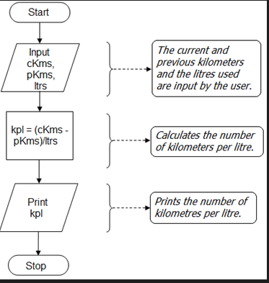

A **for** loop in JavaScript is used to iterate over a block of code multiple times.

}

* The **initialization** expression is executed once before the execution of the code block.
* The **condition** expression is evaluated before each iteration. If it evaluates to true, the code block will be executed. If it evaluates to false, the loop will terminate.
* The **iteration** expression is executed at the end of each iteration of the loop.

**Search engine optimization.**

Search engine optimization is the practice of increasing both the quality and quantity of website traffic, as well as exposure to your brand, through non-paid (also known as "organic") search engine results. It’s about understanding what people are searching for online, the answers they are seeking, the words they’re using, and the type of content they wish to consume. Knowing the answers to these questions will allow you to connect to the people who are searching online for the solutions you offer.

is the practice of increasing both the quality and quantity of website traffic, as well as exposure to your brand, through non-paid (also known as "organic") search engine results.